# CHAPTER-1

# INTRODUCTION

**1.1 PROBLEM DEFINITION**

"Timber Tales" addresses the challenge of connecting traditional wooden artisans with global markets through effective online representation. Many skilled craftsmen struggle to showcase their unique products and stories on existing e-commerce platforms, which often prioritize mass-produced goods over handcrafted excellence. This limits artisans' visibility and hampers consumer access to sustainable, high-quality wooden products. By creating a specialized online marketplace, Timber Tales aims to empower artisans, highlight the artistry and sustainability of wooden work, and educate consumers about the value of supporting traditional craftsmanship. This platform seeks to foster a renewed appreciation for handcrafted wooden items while expanding market reach for artisans worldwide.

**1.2 PROJECT OVERVIEW/SPECIFICATIONS**

"Timber Tales" is an online platform dedicated to showcasing and selling handcrafted wooden products globally. It features a user-friendly interface for artisans to upload product details, photos, and stories. Consumers can browse, purchase, and learn about the craftsmanship and sustainability of each item. The platform emphasizes quality, authenticity, and the preservation of traditional woodworking techniques.

**1.2.1 WEBSITE FEATURES:**

**User Registration and Authentication:** Secure sign-up and login for customers.

**Choose variety of woods:** This feature enables users to specify their preferred wood type for customized or ready-made wooden products.

**Choose wood designs:** This feature enables customers to specify their preferred design elements for custom or pre-designed wooden products.

**Bulk Booking System:** This feature allows customers to select and order multiple designs in a single transaction, with options for specifying quantities, customization details, and suitable designs.

**Feedback System:** Allowing customers to rate the wooden Art pieces designed by the designers.

**1.2. MODULES OF PROJECT:**

There are various modules associated with the project. These modules work in their specific areas to lead and complete the project.

**1. ADMIN**

**2. USER**

**ADMIN MODULE OF TIMBER TALES:**

Admin can view all the information about the user and edit all details about the user.

* **Admin Login:** Firstly, admin login with their account and manage the account of the registered users.
* **List:** In this section admin can view the list of customers.
* **Art Pieces:** In this section admin can manage the variety of wood pieces. (Add, Update)
* **Design:** In this section admin can manage the designs of wood art. (Add, Update)
* **View/Update booking and costing:** In this section admin books the orders and charges payment.
* **Post Previous Work:** In this section admin can post previous work done by him.

**CUSTOMER MODULES OF TIMBER TALES:**

Project provides many facilities to the users.

* **Register:** Firstly, customer register with their account and login to the website.
* **Manage Profile:** Customer can manage his/her profile.
* **View Profile:** Customer can view his/her profile.
* **View Art piece and Design:** Customer can view various Art pieces and designs of wooden items.
* **Add/View/Update Booking:** Customer can Add booking, view booking and update booking of wooden items.
* **View Posted work:** Customer can view previous post work of existing customers.

**1.3 HARDWARE REQUIREMENTS**

● Processor: Intel Core i3 or higher (e.g., Intel Core i5, Intel Core i7)

● Ram: 8 GB

● SSD:256GB

**1.4 SOFTWARE REQUIREMENTS**

● Front End: HTML, CSS, Bootstrap, JavaScript, ECMA Script, React JS

● DB Tool: Firebase Fire store

● Browser: Mozilla Firefox/Chrome/Edge or any other relevant browser

● OS: Windows operating system/Linux

● Text Editor: Visual Studio

**1.5 TECHNOLOGY USED**

**1.5.1 HTML (HyperText Markup Language)**

HTML stands for HyperText Markup Language, where:

* **HyperText** refers to the links between web pages.
* **Markup Language** denotes text between tags that define the structure of web pages.

HTML is a foundational markup language used to create and structure web pages. It defines the layout and appearance of web content through a series of elements and tags. These tags help to organize text, images, and other multimedia elements on the web page. All HTML files are saved with the .html extension, ensuring that web browsers can properly interpret and display the content.



* + 1. **CSS (Cascading Style Sheets)**

Cascading Style Sheets (CSS) is a simple yet powerful language designed to streamline the process of making web pages visually appealing. CSS allows for the separation of content from presentation, enabling developers to apply styles to web pages independently of the HTML structure.

**Benefits of CSS:**

* + - **Time-saving:** Write CSS once and reuse the same stylesheet across multiple HTML pages.
    - **Easy Maintenance:** Global changes can be made by simply updating the stylesheet, automatically reflecting changes across all web pages.
    - **Improved Search Engine Optimization (SEO):** CSS is considered clean coding, making it easier for search engines to read and index content.
    - **Enhanced Styling Capabilities:** CSS offers a broader range of styling options compared to HTML attributes, allowing for more sophisticated and aesthetically pleasing web designs.
    - **Offline Browsing:** CSS can store web applications locally using an offline cache, enabling users to access websites without an internet connection.

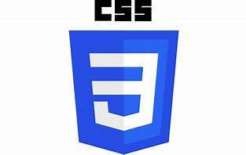

* + 1. **JAVASCRIPT**

JavaScript is a lightweight, cross-platform, and interpreted scripting language widely used for developing interactive and dynamic web pages. It is employed in both client-side and server-side development, making it a versatile tool in web development.

**Key Features of JavaScript:**

* + - **Client-side Development:** JavaScript provides objects to control a browser and its Document Object Model (DOM). This includes responding to user events such as mouse clicks, form submissions, and page navigation. Popular client-side libraries include AngularJS, ReactJS, and VueJS.
    - **Server-side Development:** JavaScript facilitates server-side operations through frameworks like Node.js. It enables applications to interact with databases, maintain session continuity, and perform file manipulations on the server.

**Incorporating JavaScript:**

* + - **Internal JavaScript:** JavaScript code can be embedded directly within an HTML file using the

<script> tag, placed either in the <head> or <body> section depending on the requirement.

* + - **External JavaScript:** JavaScript code can be written in a separate file with a .js extension and linked to the HTML document using the <script> tag within the <head> section. This approach promotes better organization and reusability of code.



* + 1. **BOOTSTRAP**

Bootstrap is a free and open-source framework designed for creating responsive and mobile-first websites and web applications. As the most popular HTML, CSS, and JavaScript framework, Bootstrap addresses many common issues in web development, including cross-browser compatibility and responsive design. Initially developed by Mark Otto and Jacob Thornton at Twitter, Bootstrap has evolved into an open-source project widely used by developers around the world.

**Benefits of Using Bootstrap:**

* + - **Faster and Easier Web Development:** Bootstrap provides pre-designed components and templates that significantly speed up the development process.
    - **Platform Independence:** Websites created with Bootstrap are platform-independent, ensuring consistent performance across different browsers and devices.
    - **Responsive Design:** Bootstrap’s responsive grid system and flexible layout options allow developers to create web pages that adapt seamlessly to various screen sizes, including desktops, tablets, and mobile phones.
    - **Mobile-First Approach:** Bootstrap is designed with a mobile-first philosophy, ensuring optimal performance on mobile devices.
    - **Free and Open Source:** Bootstrap is freely available for download at [getbootstrap.com](https://getbootstrap.com/), making it an accessible tool for developers.

**How to Use Bootstrap 5 on a Webpage:**

There are two primary methods to incorporate Bootstrap into a website:

1. **Using a CDN (Content Delivery Network):**

* Bootstrap can be included directly in your HTML file by linking to the CDN. This method is quick and easy, allowing for fast integration.

**Ex: html**

***<link rel="stylesheet" href="https://maxcdn.bootstrapcdn.com/bootstrap/4.0.0/css/bootstrap.min.css">***

***<script src="https://maxcdn.bootstrapcdn.com/bootstrap/4.0.0/js/bootstrap.min.js"></script>***

1. **Downloading Bootstrap:**

* Developers can download the Bootstrap files from [getbootstrap.com](https://getbootstrap.com/) and include them in their project directory. This method provides more control over customization and offline usage.

**Ex: html**

***<link rel="stylesheet" href="path/to/bootstrap.min.css">***

***<script src="path/to/bootstrap.min.js"></script>***

By leveraging Bootstrap, developers can create modern, responsive, and user-friendly web applications efficiently. Its comprehensive library of pre-styled components, combined with robust documentation, makes Bootstrap an essential tool in contemporary web development.



* + 1. **REACT**

React is a popular open-source JavaScript library used for building user interfaces, particularly single-page applications where efficient data rendering and dynamic content updates are essential. Developed and maintained by Facebook, React has gained widespread adoption in the developer community due to its component-based architecture and declarative programming style.

**Key Features of React:**

* + - **Component-Based Architecture:** React allows developers to build encapsulated components that manage their own state, making it easier to develop complex user interfaces by composing simple, reusable components.
    - **Declarative Syntax:** With React, developers can describe what the UI should look like for any given state, and React will efficiently update and render the necessary components when the data changes.
    - **Virtual DOM:** React utilizes a virtual DOM to optimize rendering performance. By diffing the virtual DOM with the actual DOM, React can determine the most efficient way to update the UI, minimizing direct manipulation of the DOM and improving application performance.
    - **JSX Syntax:** JSX is a syntax extension for JavaScript that allows developers to write HTML-like code within their JavaScript files. This makes it easier to visualize the structure of the UI and improves code readability.
    - **Unidirectional Data Flow:** React enforces a one-way data flow, making it easier to debug and understand the state changes within an application. This unidirectional data flow also enhances the predictability of the application's behavior.
    - **Rich Ecosystem:** React boasts a rich ecosystem of tools and libraries, including React Router for navigation, Redux for state management, and a wide array of third-party components and utilities that streamline development processes.

**Advantages of Using React:**

* + - **Efficiency and Performance:** React’s virtual DOM and optimized rendering processes result in high-performance applications, even with complex UIs.
    - **Reusable Components:** The component-based approach promotes reusability, reducing redundancy and accelerating development.
    - **Strong Community Support:** Being one of the most popular front-end libraries, React has extensive community support, comprehensive documentation, and a plethora of resources available for developers.



* **Flexibility:** React can be integrated with other libraries and frameworks, making it highly flexible for various project requirements and tech stacks.
* **How to Integrate React in a Project:**
* **Using Create React App:**
* The Create React App tool is an officially supported way to set up a new single-page React application. It provides a modern build setup with no configuration needed.
  + *npx create-react-app my-app cd my-app*
  + *npm start*
* This will create a new React application and start the development server.
* **Including React in an Existing Project:**
* For integrating React into an existing project, you can include the React and ReactDOM libraries via a CDN or install them using a package manager like npm or yarn.
  + *<script src="https://unpkg.com/react/umd/react.production.min.js"></script>*
  + *<script src="https://unpkg.com/react-dom/umd/react-dom.production.min.js"></script>*
* Or install using npm:
  + *npm install react react-dom*
* By leveraging React, developers can create dynamic, high-performance user interfaces that enhance the user experience. Its robust feature set, combined with a vast ecosystem and strong community support, makes React an excellent choice for modern web development.

**1.5.6 FIREBASE OVERVIEW**

Firebase is a platform developed by Google for creating mobile and web applications. It provides a variety of tools and services to help developers build high-quality apps, enhance user engagement, and grow their user base.

**Key Features:**

* **Real-time Database:**
* Stores and syncs data in real-time across all clients.
* Allows offline access to data.
* **Authentication:**
  + Provides easy-to-use SDKs and backend services for authenticating users.
  + Supports email/password, phone authentication, and third-party providers like Google, Facebook, and Twitter.
* **Cloud Firestore:**
  + A flexible, scalable database for mobile, web, and server development.
  + Offers real-time data synchronization and offline support.
* **Cloud Storage:**
  + Designed to help you store and serve user-generated content like photos and videos.
* **Hosting:**
  + Provides fast, secure hosting for web applications, static and dynamic content.
  + Includes built-in SSL, global CDN, and other security features.
* **Cloud Functions:**
  + Let’s you run backend code in response to events triggered by Firebase features and HTTPS requests.
  + Scales automatically.
* **Analytics:**
  + Offers insights into user behaviour and app performance.
  + Helps track key metrics and make informed decisions.
* **Crashlytics:**
  + A powerful, real-time crash reporting tool that helps you prioritize and fix stability issues faster.
* **Firebase Performance Monitoring:**
  + Helps you understand where and when your app's performance can be improved.
* **Benefits of Using Firebase:**
* **Integrated Environment:** All Firebase services work well together, providing a seamless development experience.
* **Scalability:** Automatically scales with your app, handling increased load without additional configuration.
* **Cross-Platform:** Supports both iOS and Android platforms, enabling a consistent user experience.
* **Secure:** Provides robust security features to protect your app and user data.
* Firebase is a comprehensive solution for app development, providing a suite of tools that cover everything from backend infrastructure to user engagement. It simplifies the development process, allowing you to focus on building great user experiences.



**CHAPTER-2**

**LITERATURE SURVEY**

**2.1 EXISTING SYSTEM**

The existing system of offline wooden work typically revolves around traditional craftsmanship methods and local artisanal practices.

**Here's a detailed overview:**

**2.1.1 Artisanal Expertise:** Offline wooden work relies heavily on the skills and expertise of local craftsmen who have inherited and honed their techniques over generations. These artisans often specialize in specific types of woodworking, such as furniture making, carving, turning, or joinery.

**2.1.2 Workshop Setup:** Artisans typically work in small-scale workshops or studios equipped with traditional hand tools and occasionally modern machinery. These workshops are often located in regions known for their timber resources, fostering a close connection between material sourcing and craftsmanship.

**2.1.3 Customization and Personalization:** Offline wooden work places a strong emphasis on customization and personalization. Customers can visit workshops, discuss their requirements directly with artisans, and sometimes even witness the creation process firsthand. This direct interaction allows for bespoke designs tailored to individual preferences.

**2.1.4 Market Access:** While offline, the market reach for artisans is limited to local or regional customers unless they participate in craft fairs, exhibitions, or collaborate with retail outlets. This traditional approach can sometimes restrict the visibility and scalability of artisanal businesses compared to online platforms.

**2.1.5 Challenges:** Challenges in the offline wooden work industry include limited exposure to broader markets, fluctuations in demand, and competition from mass-produced alternatives. Moreover, finding skilled apprentices to continue the legacy of craftsmanship poses a significant challenge in some regions.

Overall, the existing system of offline wooden work celebrates artisanal skill, promotes sustainability, and preserves cultural heritage while facing challenges related to market access and modernization.

**2.2 PROPOSED SYSTEM**

**DESCRIPTION OF THE NEW SYSTEM**

Timber Tales aims to bridge these gaps by providing a dedicated online platform that celebrates the artistry and craftsmanship of woodworking. By showcasing curated collections of handcrafted wooden products, Timber Tales enables artisans to reach a global audience, fostering appreciation for their skills and dedication.

**2.2.1 User Registration and Authentication:** Secure sign-up and login processes for customers.

**2.2.2 Choose wood designs:** This feature enables customers to specify their preferred design elements for custom or pre-designed wooden products.

**2.2.3 Bulk Booking System:** This feature allows customers to select and order multiple designs in a single transaction, with options for specifying quantities, customization details, and suitable designs.

**2.2.4 Feedback System:** Allowing customers to rate the wooden Art pieces designed by the designers.

**2.3 FEASIBILITY STUDY**

**2.3.1 MARKET FEASIBILITY:**

* **Market Analysis:** Evaluate the current market for online wooden products. Identify trends, customer preferences, and competition in the online marketplace. Consider factors such as consumer demand for handmade, bespoke items, sustainability concerns, and pricing sensitivity.
* **Target Audience:** Define your target audience, including demographics (age, location, income), interests (home decor, eco-friendly products), and purchasing behaviour (online shopping habits, preferences for customization).
* **Competitive Analysis:** Assess competitors offering similar products online. Identify their strengths, weaknesses, pricing strategies, product offerings, and customer reviews. Determine how Timber Tales can differentiate itself in terms of product quality, customization options, customer service, and branding.

**2.3.2TECHNICAL FEASIBILITY:**

* **Website Development:** Evaluate the technical requirements for developing and maintaining an e-commerce platform for Timber Tales. Consider factors such as website design, functionality (e.g., product customization tools, payment gateways), scalability, and security (data protection, secure transactions).
* **Logistics and Operations:** Assess logistics for sourcing raw materials, production processes, inventory management, packaging, and shipping. Determine how to optimize efficiency while maintaining product quality and meeting customer expectations.

**2.3.3 FINANCIAL FEASIBILITY:**

* **Cost Estimation:** Calculate initial startup costs, including website development, equipment (if applicable), marketing and advertising expenses, initial inventory, and operational expenses (rent, utilities, salaries).
* **Revenue Projections:** Forecast revenue based on pricing strategy, sales projections, and expected profit margins. Consider seasonal variations, market trends, and customer acquisition costs.
* **Break-Even Analysis:** Determine the time required to reach break-even point based on projected expenses and revenue. Evaluate the sustainability of cash flow and profitability over the short-term and long-term.

**2.3.4 OPERATIONAL FEASIBILITY:**

* **Supplier and Partner Relationships:** Identify potential suppliers for wood materials and other supplies. Evaluate partnerships with artisans or woodworking studios for collaboration or product sourcing.
* **Production Capacity:** Assess the capability to meet customer demand while maintaining product quality and timely delivery. Consider scalability options as demand grows.
* **Customer Service:** Define customer service standards and processes for handling inquiries, customization requests, returns, and feedback. Ensure a seamless and positive customer experience to build brand loyalty.

**2.3.5 LEGAL AND REGULATORY FEASIBILITY:**

* **Legal Requirements:** Identify legal considerations such as business registration, permits, licenses, tax obligations, and compliance with consumer protection laws (e.g., online sales regulations, data privacy laws).
* **Intellectual Property:** Evaluate protections for trademarks, copyrights (e.g., original designs), and any licensing agreements related to branded products or partnerships.

**CHAPTER-3**

**SYSTEM ANALYSIS & DESIGN**

**3.1 REQUIREMENT SPECIFICATION**

**3.1.1 FUNCTIONAL REQUIREMENTS:**

**1. USER REGISTRATION AND AUTHENTICATION:**

* **User Registration:** Customer must be able to register on the platform using their email, phone number, or social media accounts.
* **User Authentication:** Secure login functionality, including password recovery and multi-factor authentication.
* **Role Management:** Differentiated roles for customers and admin with distinct access permissions.

**2.CHOOSE VARIETY OF ARTPIECES:**

* **Art-pieces:** This feature also enables users to choose the Art pieces wooden products.

**3.CHOOSE ART DESIGNS:**

* **Art Design:** This feature enables customers to specify their preferred design elements for custom or pre-designed wooden art pieces products.

**4 BULK BOOKING SYSTEM:**

* **Add Booking:** This feature allows customers to select and order multiple designs in a single transaction, with options for specifying quantities, customization details, and suitable designs.
* **Update Booking:** Customer can also update this/her previous bookings.

**5. FEEDBACK SYSTEM:**

* **Rating and Review:** Customers can rate the wood designs, Art pieces and provide reviews.
* **Feedback Analysis:** Collection of feedback data for service improvement.

**3.1.2 NON-FUNCTIONAL REQUIREMENTS:**

**1. PERFORMANCE:**

* **Load Handling:** System must support concurrent access by multiple users without performance degradation.
* **Response Time:** Quick response times for user actions, such as form submissions and data retrieval.

**2. SECURITY:**

* **Data Protection:** Encryption of data both in transit and at rest.
* **User Privacy:** Compliance with data protection regulations (e.g., GDPR).

**3. USABILITY:**

* **User Interface:** Intuitive and user-friendly interface accessible to users with varying levels of technical proficiency.
* **Accessibility:** Compliance with accessibility standards to support users with disabilities.

**4.SCALABILITY:**

* **Scalable Architecture:** Ability to scale horizontally to accommodate increasing user numbers.
* **Cloud Integration:** Utilization of cloud services for scalability and reliability.

### **3.2 DATA ANALYSIS**

Before developing this project, we first analyzed the existing systems within the timber market. Traditional methods of designing wooden works are largely manual, lacking the efficiency and accuracy provided by modern technology. Given the ubiquity of computers in contemporary commerce, automating these processes is both necessary and feasible. We evaluated the technical, economic, and operational feasibility of the project, ensuring it would meet the needs of users effectively.

Our analysis involved a thorough examination of the existing market systems, assessing their limitations and potential for improvement. We designed the system with these insights and implemented it to verify its functionality and user-friendliness. Post-implementation, we conducted user testing to identify and resolve any issues.

#### **Types of Analysis:**

There are various measures of analysis that help decide whether a particular project is feasible. These measures include:

* **Operational Analysis**
* **Technical Analysis**
* **Economic Analysis**

### **1. Operational Analysis**

The success of any proposed system for "Timber Tales" hinges on its seamless integration into existing operations and its acceptance by users. Key considerations for system developers include:

**User Adoption:** Will the new system be embraced and effectively utilized by all stakeholders, including artisans, administrators, and customers?

**Implementation Barriers:** Are there significant obstacles to implementing the system, or will it be accepted smoothly without resistance?

The primary objective of computerizing online wooden work at "Timber Tales" is to enhance transaction accuracy and efficiency while reducing time consumption. The proposed computerized system includes a comprehensive database accessible to administrators, artisans (users), and customers alike. This system promises to minimize errors significantly compared to semi-computerized methods by alleviating user burden and preventing inadvertent mistakes. Furthermore, it ensures secure data backup, safeguarding transactional integrity.

Security control is paramount due to the confidentiality of customer and transaction data. A robust security framework is essential to prevent unauthorized access and protect against potential fraud and data breaches. Unlike semi-computerized systems, the proposed system at "Timber Tales" incorporates individual login credentials for enhanced security.

Moreover, the system is designed to be user-friendly, facilitating efficient and accurate task completion for artisans and seamless shopping experiences for customers.

In conclusion, the proposed computerized system for "Timber Tales" demonstrates strong operational feasibility by addressing key operational requirements, enhancing efficiency, ensuring data security, and promoting user acceptance.

### **2. Economic Analysis**

The economic viability of implementing a computerized system for "Timber Tales" in the online wooden work sector hinges on several critical factors:

**Cost Efficiency:** Transitioning to a computerized system aims to enhance transaction accuracy and efficiency while reducing operational costs associated with manual processes. By minimizing errors and streamlining operations, the system is expected to optimize resource allocation and improve overall cost-effectiveness.

**Revenue Generation:** The proposed system is designed to facilitate seamless transactions between artisans, administrators, and customers, potentially increasing sales volumes and revenue streams. Enhanced efficiency in order processing and customer service could lead to higher customer satisfaction and repeat business.

**Market Competitiveness:** In a competitive online market for wooden products, the ability to offer a user-friendly interface and secure transactions through a robust computerized system can differentiate "Timber Tales" from competitors. This competitive advantage could potentially attract more customers and expand market share.

### **3.Technical Analysis**

**Comprehensive Database Integration:** The system integrates a robust database accessible to administrators, artisans, and customers. This integration enhances transaction accuracy and efficiency by centralizing data management. It minimizes errors associated with semi-computerized methods, thereby reducing time consumption and enhancing operational reliability.

**Enhanced Security Measures:** Security measures are paramount to protect customer and transaction data. The system employs individual login credentials and a robust security framework to prevent unauthorized access, ensuring data integrity and safeguarding against potential fraud and breaches. This approach contrasts with less secure semi-computerized systems, promising a safer online environment for users.

**User-Friendly Interface:** Designed for ease of use, the system features a user-friendly interface that facilitates efficient task completion for artisans and seamless shopping experiences for customers. This design consideration aims to promote user acceptance and adoption among all stakeholders, crucial for the system's success.

**Operational Feasibility and Efficiency:** The proposed system demonstrates strong operational feasibility by addressing critical operational requirements. It enhances overall efficiency by streamlining processes, reducing manual effort, and improving accuracy in online wooden work transactions. This efficiency gain translates into improved service delivery and customer satisfaction, essential for maintaining competitive advantage in the market.

By focusing on these four points—database integration, security measures, user-friendly interface, and operational feasibility—the technical analysis highlights how the proposed system for "Timber Tales" aligns with key objectives of enhancing efficiency, ensuring data security, and promoting user acceptance in the context of online wooden work.

# 3.3 DATA FLOW DIAGRAM

Data Flow Diagrams were first developed by Larry Constantine as a way of expressing system requirements in a graphical form. DFD is also known as bubble chart and has a purpose of clarifying system requirements and identifying major transformations and will become the program in the system design.

Data Flow Diagramming is a means of representing a system at any level of detail with a graphic network of symbols showing data flows, data stores, data processes, and data sources/destinations.

#### **PURPOSE:**

The purpose of data flow diagrams is to provide a semantic bridge between users and systems developers.

#### **The diagrams are:**

● Graphical, eliminating thousands of words.

● Logical representations, modeling WHAT a system does, rather than physical models showing HOW it does it.

● Hierarchical, showing systems at any level of detail and

● Allowing user understanding and reviewing.

### **DFD Symbols are as follows:**

* The External Entity symbol represents sources of data to the system or destinations of data from the system.
* The Data Flow symbol represents the movement of data.
* The Data Store symbol represents data that is not moving (delayed data at rest).
* The Process symbol represents an activity that transforms or manipulates the data.

### **DFD Level 0**

Context Level Diagram

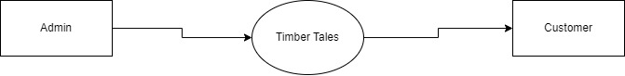

Here User and Admin interact with the system for different purposes. Database contains all the information which users need.

**Level 0 DFD: DFD for Admin**

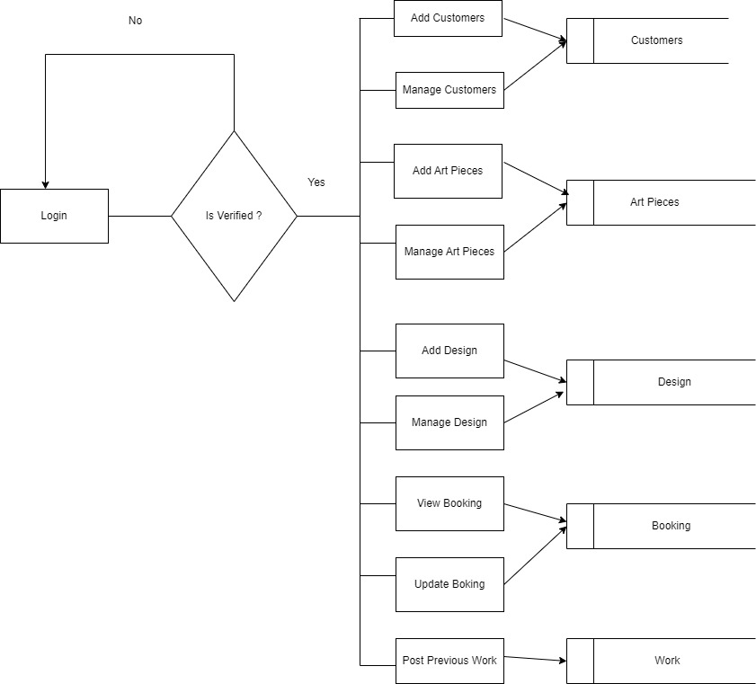

**Level 1 DFD: DFD for User**

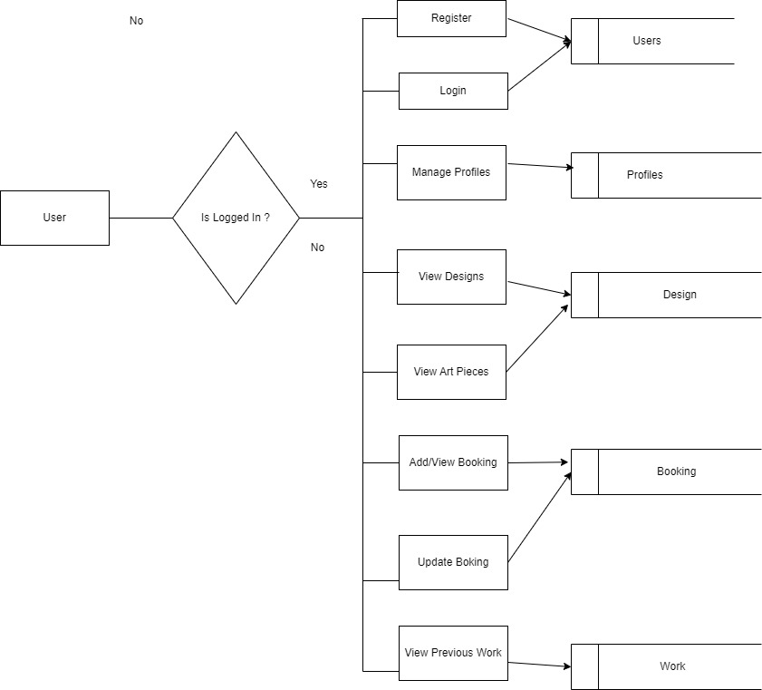

**3.4 DESIGN**

**3.4.1 SYSTEM DESIGN**

The design phase of the Software Development Life Cycle (SDLC) is a pivotal and creative stage that transforms the requirements defined during the analysis phase into a blueprint for constructing the final system. This phase encompasses the creation of detailed specifications for both the software and the hardware, as well as the construction and testing of programs.

The primary objective of the design phase is to devise a plan to solve the problems outlined in the requirements document. This phase represents the initial step in transitioning from the problem domain to the solution domain, moving from identifying what is needed to determining how to fulfill those needs. The design phase is crucial as it significantly influences the quality of the software and impacts subsequent phases, particularly testing and maintenance. The result of this phase is a comprehensive design document, which serves as a blueprint for implementation, testing, and maintenance.

**3.4.2 Design Methodology**

A systematic approach is essential for achieving a successful system design. This methodology begins with an initial concept and develops it through a series of well-defined steps. The following steps outline the process for effective system development:

* + 1. **Problem Analysis:** Thoroughly understand the problem to be solved and the goals to be achieved.
    2. **Output Requirements:** Determine the desired output and the type of input required to achieve this output, ensuring that the system delivers the expected results.
    3. **Database Design:** Design the structure of various databases based on the output requirements, ensuring data integrity and accessibility.
    4. **Program Development:** Develop individual programs that contribute to solving the overall problem, focusing on modularity and reusability.
    5. **Program Testing:** Test each program individually, making necessary corrections to ensure functionality and accuracy.
    6. **Integration:** Combine all programs into a cohesive system, ensuring seamless interaction between different modules.
    7. **System Testing:** Conduct comprehensive testing of the integrated system to identify and rectify any issues, ensuring the system meets all specified requirements.
    8. **Documentation:** Produce detailed documentation, including design specifications, user manuals, and maintenance guides, to support future development and maintenance activities.

**3.4.3 Design Objectives**

The design phase must consider three main objectives to ensure the system's effectiveness:

* + 1. **Performance:** Ensure the design enables the system to perform tasks efficiently given the available hardware resources.
    2. **Security:** Design the system to be robust against human errors and machine malfunctions, incorporating measures to protect against security breaches and data loss.
    3. **Flexibility:** Ensure the design allows for easy modifications and updates, facilitating future enhancements and maintenance.

**3.4.4 Design Approaches**

To meet these objectives, two primary design approaches are utilized: top-down design and bottom-up design.

**Top-Down Design:**

* + - * Also known as system design, this approach starts with a broad overview and moves towards detailed specifications. It focuses on identifying major system functions and breaking them down into smaller, manageable activities. This approach is suitable for understanding the overall system architecture and ensuring all components are considered.

**Bottom-Up Design:**

* + - * Also known as detailed design, this approach starts with specific details and builds up to a comprehensive system overview. It is appropriate when users have clear requirements for outputs, and it focuses on designing individual components that are later integrated into the overall system.

**Conclusion**

The design phase is critical for laying the foundation of a successful software project. By following a systematic methodology and focusing on key design objectives, we ensure that the resulting system is efficient, secure, and flexible. The design document produced during this phase serves as a crucial guide for implementation, testing, and maintenance, ultimately contributing to the overall success of the project.

**3.5 TESTING PROCESS.**

Testing is the major quality control measure employed during software development. Testing is the process of executing a program with the intent of finding an error. No piece of code is completely ready unless it has been fully tested. This stage is very important as at this stage it is verified whether the code developed meets the requirement specifications or not. Moreover, all validations are also checked in the testing stage.

Testing is a process of executing a program with the intent of finding an error. A good test case is the one that has a probability of finding an as yet undiscovered error. If testing is conducted successfully (according to the objective stated) it will uncover errors in the software. As a secondary benefit, testing demonstrates that software function appears to be working according to the specification that performance requirement appears to have been met.

Testing is the set of activities that can be planned in advance and conducted systematically. It is an integral part of program development. It is in this stage, where we check that the program that has been coded, Perform according to the requirements. The purpose of doing the test is not to demonstrate that there are no errors in the program but to detect any bugs that may still exist.

In the testing stage, the main aim is to look for errors that unknowingly have occurred. It is a common misconception that the purpose of testing is to prove that a program is working correctly. This is a dangerous myth because it can lead to insufficient testing, and programs with hidden faults. Because the actual result and expected result may differ in the field of reality and it can be hazardous for a program.

The importance of software testing and its implications with respect to software quality cannot be over emphasized. Software testing is a crucial element of software quality and represents the ultimate review of specification design and coding.

The increasing visibility of motivating forces for well-planned thorough testing. It is not unusual for software development organizations to expend 40% of total project effort on testing.

**3.5.1 TEST STRATEGY**

Implemented System is tested using Basic levels of Testing that are:

**1) UNIT TESTING.**

**2) INTEGRATION TESTING.**

**3) SYSTEM TESTING.**

**4) ACCEPTANCE TESTING.**

These different levels of testing attempt to detect different types of faults. The relation of the faults introduced in different phases, and the different levels of testing are shown:

**1.) UNIT TESTING**

The first level of testing is unit testing. In this different module are tested against the specifications produced during design for the modules. Unit testing is essential for verification of the code produced during the coding phase and hence the goal is to test the internal logic of the modules.

**2.) INTEGRATION TESTING**

The next level of testing is often called integration testing. In this many tested modules are combined into sub-systems, which are then tested the goal here is to see if the modules can be integrated properly, the emphasis being on testing interfaces between modules. This activity can be considered as testing the design, and hence the emphasis on testing module interactions.

**3.) SYSTEM TESTING**

The next level of testing is system testing. Here the entire software system is tested. The reference document for this process is a requirement document, and the goal is to see if the software meets its requirements. This is essentially a validation exercise. And it was found that they all are working well to meet the Owners requirements.

**4.) ACCEPTANCE TESTING**

The last level of testing is acceptance testing. Acceptance testing is performed with realistic data of the client to demonstrate that the software is working satisfactorily. Testing here focuses on the external behavior of the system; the internal logic of the program is not emphasized.

**3.5.2 TEST CASES**

For testing to be successful, proper selection of test cases is essential. There are two different approaches to selecting cases - functional testing and structural testing.

* Non-Functional testing of the software or the module to be tested is treated as a black box, and the test cases are decided based on the specifications of the system or the module. For this reason this type of testing is also called "black box testing" the focus here is on testing the external behavior of the system.
* In structural testing the test cases are decided based on the logic of the module to be tested. A common approach here is to achieve some type of coverage of the statements in the code. One common coverage criterion is statement coverage, which requires that test cases be selected so that together they execute each statement exactly once.

**Test Case 1**

|  |  |
| --- | --- |
| Test Case Identification | Login Screen |
| Expected Results | It should display the message invalid login parameters. |
| Actual Results | It displays the error message invalid login parameters. |
| Remarks | Pass |

When User accidently enters a wrong username and password combination, then error message will display invalid username or password.

**Test Case 2**

|  |  |
| --- | --- |
| Test Case Identification | New Account Screen |
| Expected Results | It should display the message for the fields which is required to fill. |
| Actual Results | It displays the error message Please enter your name, Please enter your Phone Number etc. |
| Remarks | Pass |

When any user accidentally submits the data without filling in full details, then an error message will display.

**Test Case 3**

|  |  |
| --- | --- |
| Test Case Identification | New Account Screen |
| Expected Results | It should display the message Please enter the correct email. |
| Actual Results | It displays the error message Please enter the correct email. |
| Remarks | Pass |

When a user enters the wrong email address on creating a new account page, then the error message will display “Please enter the correct email”.

**3.6 SOFTWARE PROCESS MODEL**

The software development process for the agriculture e-commerce website is structured using the Agile methodology. Agile is chosen due to its iterative and incremental nature, which promotes flexibility, continuous improvement, and rapid delivery of functional software components. This chapter details the Agile process model and its application to the project.

**OVERVIEW OF AGILE METHODOLOGY**

Agile methodology is an approach to software development that emphasizes flexibility, collaboration, and customer satisfaction. Unlike traditional methodologies, Agile focuses on delivering small, incremental improvements to the software rather than a complete product at the end. This approach enables teams to adapt to changes more effectively and deliver value to stakeholders continuously.

**KEY PRINCIPLES OF AGILE:**

* **Customer Collaboration:** Active involvement of customers throughout the development process ensures that the final product meets their needs and expectations.
* **Incremental Delivery:** Software is developed and delivered in small, functional increments, allowing for regular feedback and adjustments.
* **Adaptability:** Agile processes accommodate changing requirements, even late in development, ensuring the product remains relevant.
* **Cross-Functional Teams:** Teams are composed of individuals with varied skills who work collaboratively to complete tasks.
* **Continuous Improvement:** Regular reflection and adaptation of processes enhance team efficiency and product quality.

**3.6.1 APPLICATION OF AGILE TO THE PROJECT**

**PROJECT PHASES**

**1. INITIATION AND PLANNING.**

* **Define Objectives:** Establish the goals and scope of the timber works e-commerce website, including key functionalities such as product listing, user registration, and transaction management.
* **Form the Team:** Assemble a cross-functional team with skills in front-end and back-end development, database management, and user experience design.
* **Create Backlog:** Develop a product backlog containing user stories that outline the required features and functionalities.

**2. SPRINT PLANNING.**

* **Select User Stories:** Prioritize and select user stories from the product backlog for the upcoming sprint, typically lasting 2-4 weeks.
* **Define Tasks:** Break down user stories into smaller, manageable tasks and assign them to team members.
* **Set Goals:** Establish sprint goals that align with the overall project objectives.

**3. DEVELOPMENT.**

* **Implement Features:** Develop the selected features and functionalities according to the user stories and tasks defined in the sprint planning.
* **Daily Stand-Ups:** Conduct daily stand-up meetings to discuss progress, identify obstacles, and plan daily activities.

**4. TESTING.**

* **Unit Testing:** Test individual components to ensure they function correctly.
* **Integration Testing:** Verify that integrated components work together seamlessly.
* **User Acceptance Testing:** Involve stakeholders to validate that the implemented features meet their requirements.

**5. REVIEW AND RETROSPECTIVE.**

* **Sprint Review:** Demonstrate the completed work to stakeholders and gather feedback.
* **Sprint Retrospective:** Reflect on the sprint to identify areas for improvement and implement changes in the next sprint.

**6. DEPLOYMENT:**

* **Deploy Increment:** Release the functional increment of the software to the production environment.
* **Monitor and Support:** Monitor the deployed increment for any issues and provide ongoing support.

**7. TOOLS AND TECHNOLOGIES.**

* **Project Management:** Jira or Trello for managing the product backlog, sprints, and tasks.
* **Version Control:** Git for source code management and collaboration.
* **Continuous Integration/Continuous Deployment (CI/CD):** Jenkins or GitHub Actions for automated testing and deployment.
* **Communication:** Slack or Microsoft Teams for team communication and collaboration.

**8. BENEFITS OF AGILE FOR THE PROJECT**

* **Enhanced Flexibility:** Agile allows for adjustments to be made quickly in response to changing requirements or feedback.
* **Improved Stakeholder Engagement:** Regular involvement of stakeholders ensures the project stays aligned with their needs.
* **Continuous Delivery:** Incremental delivery of functional software provides value to users early and often.
* **Higher Quality:** Continuous testing and feedback loops lead to early detection and resolution of issues.

**Conclusion**

The adoption of the Agile methodology for the development of the timber works e-commerce website ensures a flexible, collaborative, and efficient process. By focusing on incremental delivery and continuous improvement, the project aims to deliver a high-quality product that meets user needs and adapts to evolving requirements.

**3.7 IMPLEMENTATION**

System implementation generally benefits from high levels of user involvement and management support. User participation in the design and operation of information systems has several positive results. First, if users are heavily involved in systems design, they move opportunities to mold the system according to their priorities and business requirements, and more opportunities to control the outcome. Second, they are more likely to react positively to the change process. Incorporating user knowledge and expertise leads to better solutions. The relationship between users and information systems specialists has traditionally been a problem area for information systems implementation efforts. This is referred to as the user-designer communications gap. These differences lead to divergent organizational loyalties, approaches to problem- solving, and vocabularies. Examples of these differences or concerns are below:

1. **User Concerns**
   * Will the system deliver the information I need for my work?
   * How quickly can I access the data?
   * How easily can I retrieve the data?
   * How much clerical support will I need to enter data into the system?
   * How will the operation of the system fit into my daily business schedule?
2. **Designer Concerns**
   * How much disk storage space will the master file consume?
   * How many lines of program code will it take to perform this function?
   * How can we cut down on CPU time when we run the system?
   * What are the most efficient ways of storing this data?
   * What database management system should we use?

**3.8 MAINTENANCE**

**INTRODUCTION TO SOFTWARE MAINTENANCE**

Software maintenance denotes any changes made to a software product after it has been delivered to the customer. Maintenance is inevitable for almost any kind of product. It is practically impossible to make the software completely error-free because the input domain of most software products is very large and it is not practical to test the software exhaustively with respect to each value that the input data may assume. Maintenance is also needed to enhance the features of the software to add more functionality to it and to port to new platforms etc.

**Types of Software Maintenance**

Maintenance is fixing or enhancing a system. Many different types of maintenance must be performed on the system to ensure it continues to operate as expected. These include:

* **Adaptive maintenance -** making changes to increase system functionality to meet new requirements.
* **Corrective maintenance -** making changes to repair system defects and bugs observed while the system is in use.
* **Perfective maintenance -** making changes to enhance the system and improve such things as processing performance and usability.
* **Preventive maintenance -** making changes to reduce the chance of future system failures.

**CHAPTER-4**

**RESULTS / OUTPUTS**

## **Login-page**

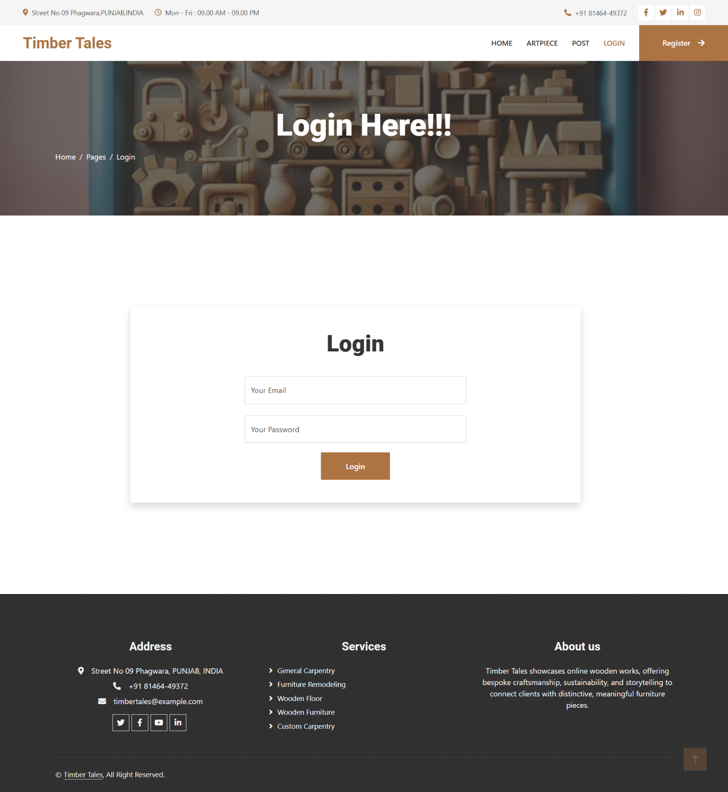

**Home Page**

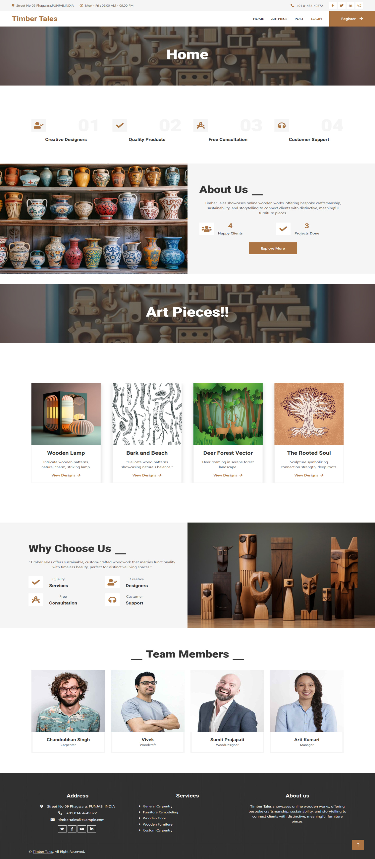

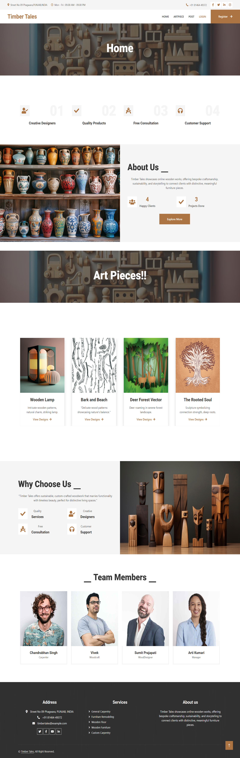

**Add Art piece Page**

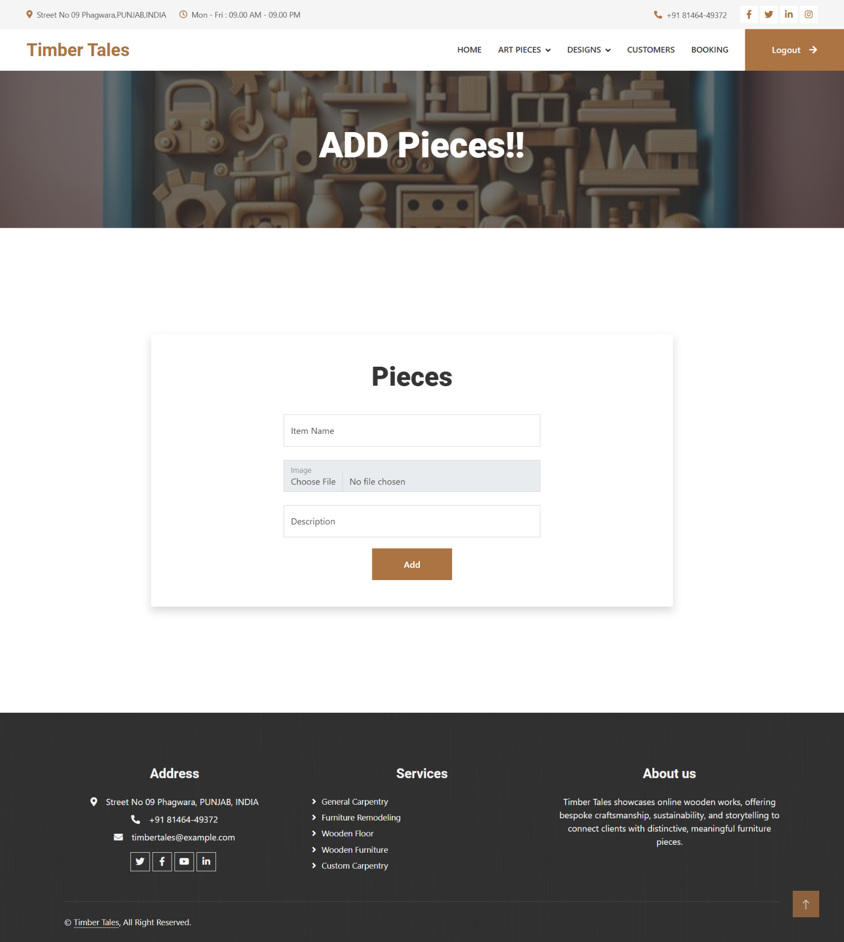

**Add Design Page**

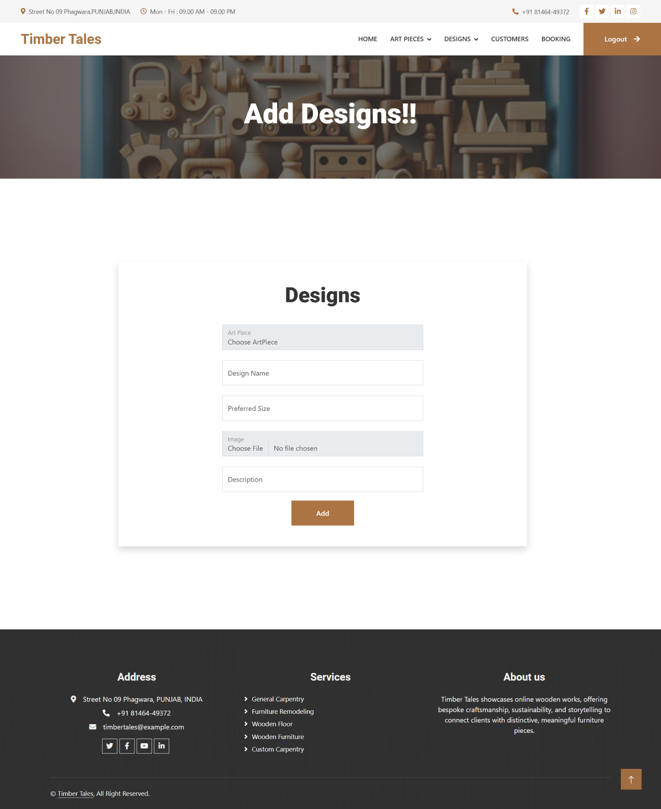

**Manage Art Piece Page**

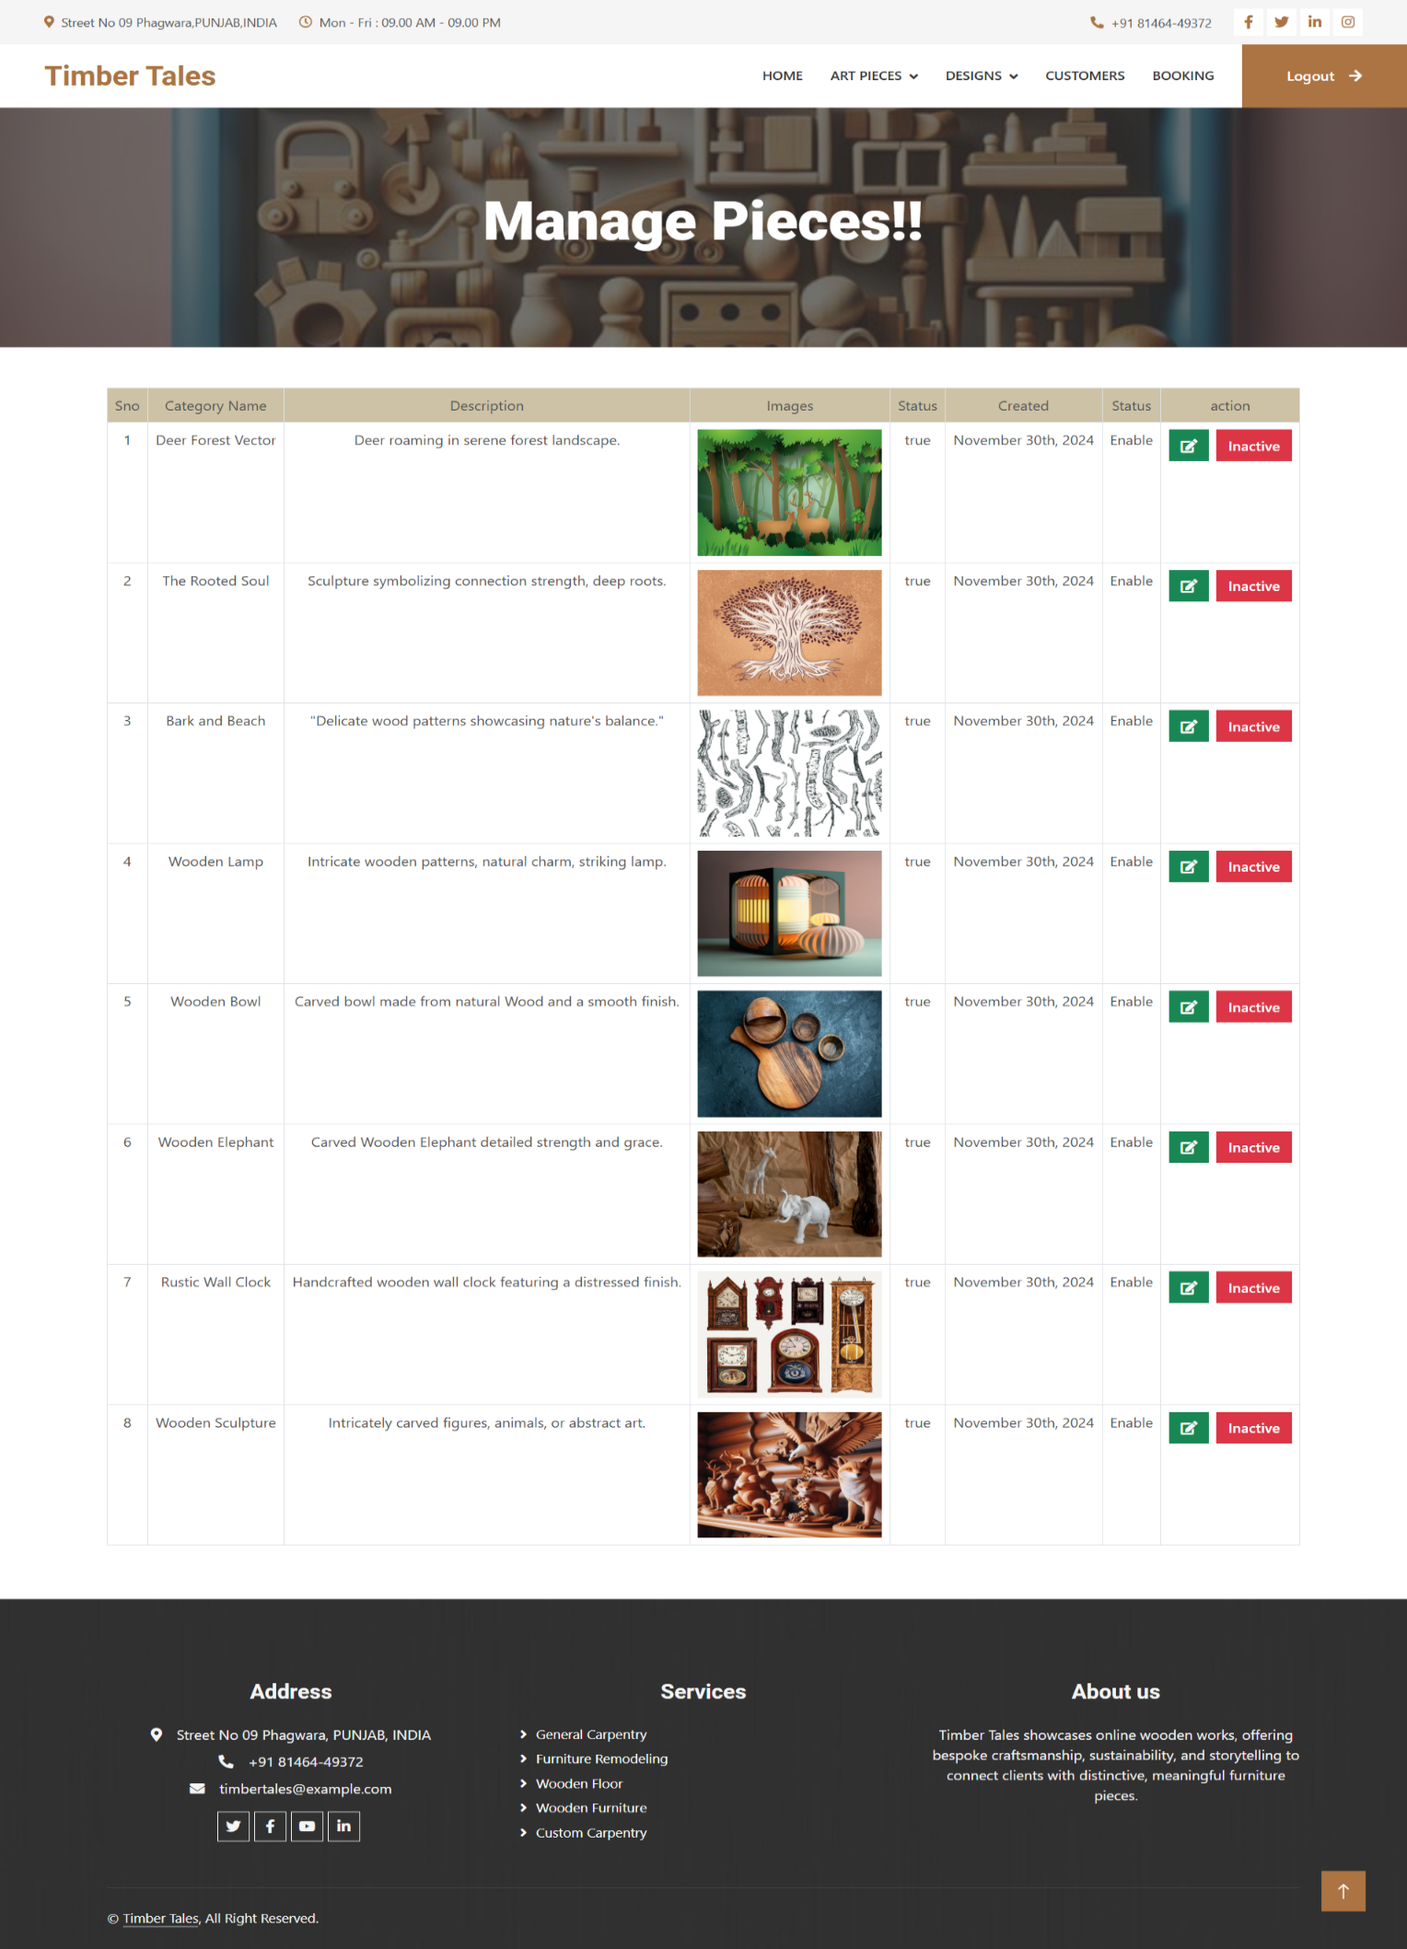

**List Of Customers**

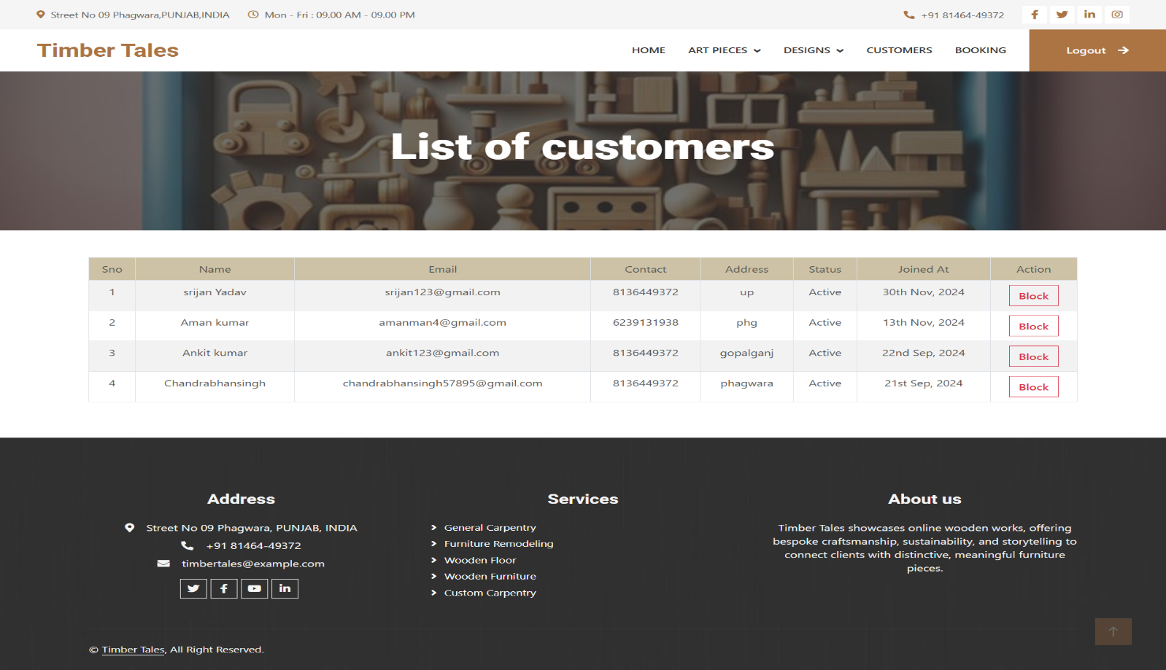

**Booking History**

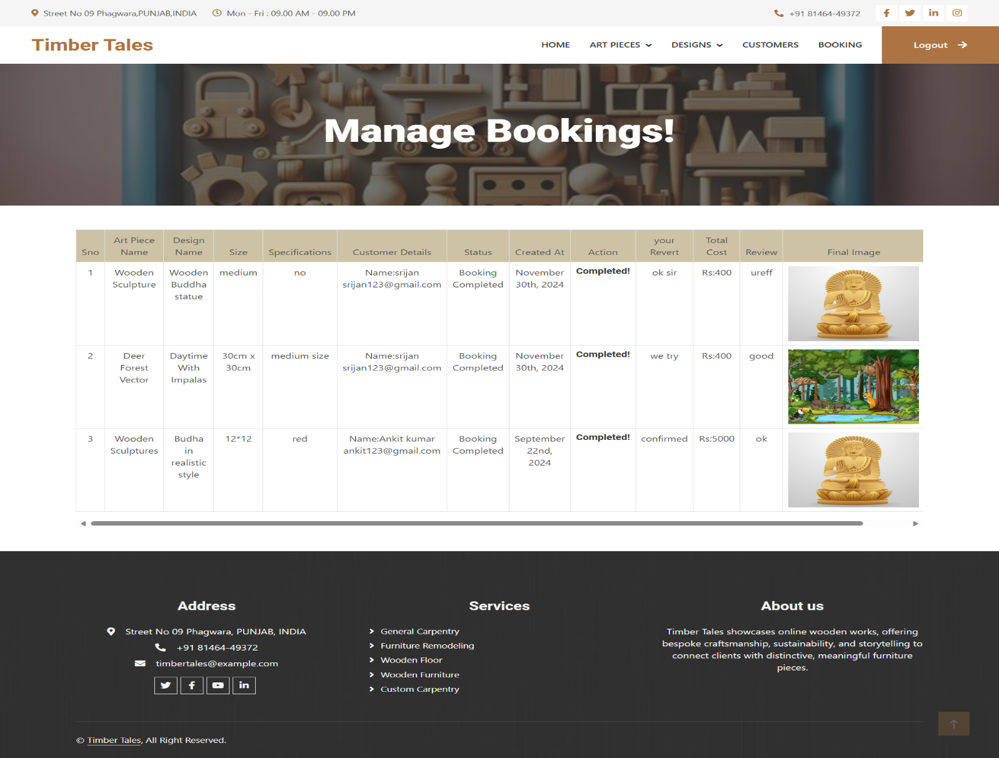

**Dashboard**

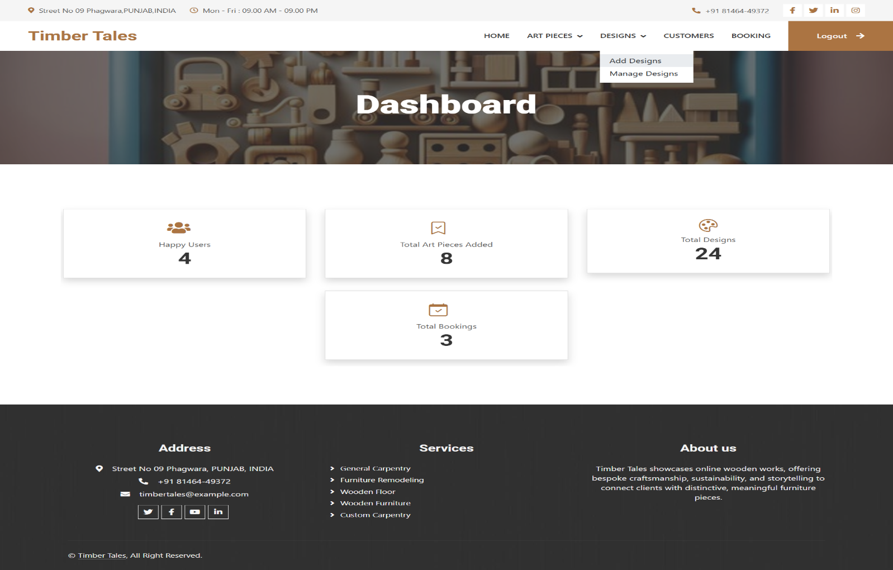

**Art Piece Page**

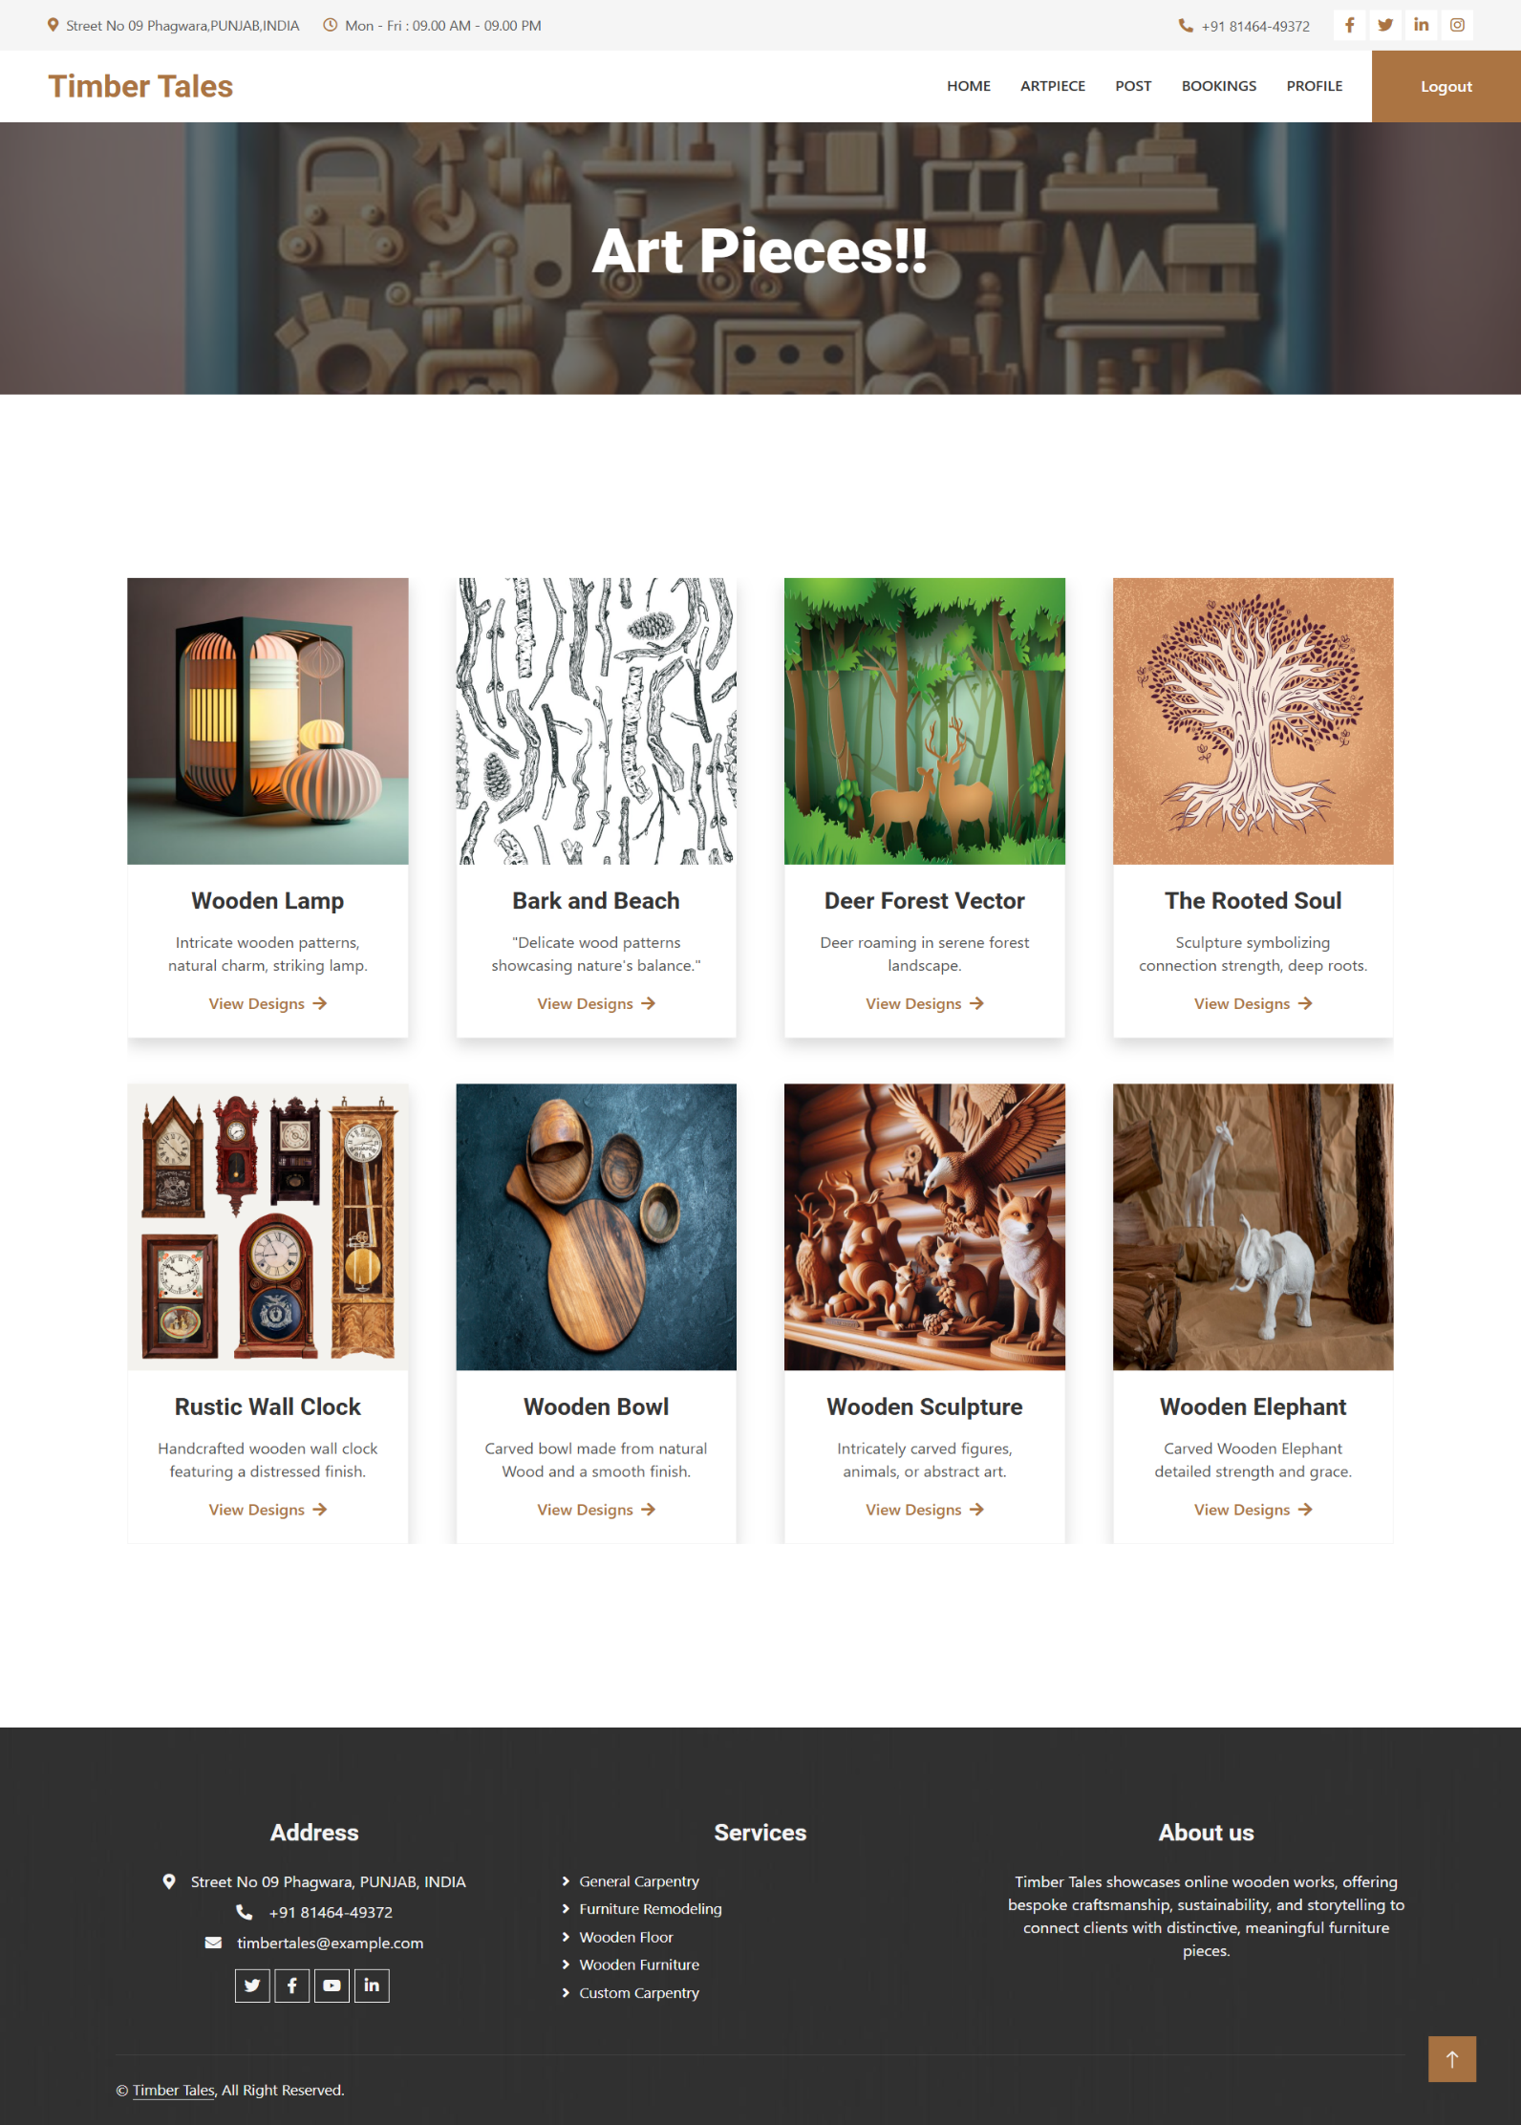

**CHAPTER-5**

**CONCLUSION**

**5.1 CONCLUSIONS**

The proposed computerized system for "Timber Tales" represents a significant advancement in managing online wooden work, aimed at improving transactional accuracy, efficiency, and overall user experience. By integrating a comprehensive database accessible to artisans, administrators, and customers alike, the system addresses key operational challenges and enhances service delivery. Security measures ensure the confidentiality and integrity of customer and transaction data, setting it apart from semi-computerized methods. The user-friendly interface further promotes adoption and efficiency among stakeholders, contributing to streamlined operations and customer satisfaction.

**5.2 RECOMMENDATIONS**

**RECOMMENDATIONS**

1. **Enhance User Engagement**
   * Introduce personalized recommendations based on user preferences and browsing history to improve customer satisfaction.
2. **Streamline the Booking Process**
   * Add real-time order tracking and notifications to keep users updated about their booked art pieces.
3. **Expand Feedback Options**
   * Allow users to upload images of received products with reviews, enhancing credibility and inspiring potential customers.
4. **Optimize Admin Tools**
   * Implement analytics dashboards for admins to monitor user behavior, sales trends, and design popularity effectively.
5. **Incorporate Sustainability**
   * Highlight eco-friendly materials and crafting practices to attract environmentally conscious customers.

These recommendations strengthen **Timber Tales** by enhancing operational efficiency, scalability, and user satisfaction. By leveraging feedback, mobile accessibility, data analytics, and cybersecurity, the platform ensures agility, responsiveness, and secure delivery of exceptional wooden art experiences.

**CHAPTER-6**

**REFERENCES**

**REFERENCES FOR TIMBER TALES**

1. **Examples of Wooden Art and Craft Platforms**
   * [**Etsy**](https://www.etsy.com/) (Global)  
     **Focus:** A marketplace for handmade and custom wooden art pieces.  
     **Inspiration:** Its personalized search and custom ordering features.
   * [**ArtFire**](https://www.artfire.com/) (Global)  
     **Focus:** A platform for independent artists to showcase and sell their work, including wooden crafts.  
     **Inspiration:** Community-building and showcasing artist portfolios.
   * [**Wooden Street**](https://www.woodenstreet.com/) (India)  
     **Focus:** Custom wooden furniture and art pieces for homes and offices.  
     **Inspiration:** Their user-friendly design tools and customization options.
2. **Educational and Video Resources**
   * [**YouTube - Woodworking for Mere Mortals**](https://www.youtube.com/user/stevinmarin)  
     **Inspiration:** Tutorials on crafting techniques and DIY wooden projects.
   * [**The Wood Whisperer**](https://thewoodwhisperer.com/) (Global)  
     **Focus:** Guides and videos on woodworking techniques and tips.  
     **Inspiration:** Engaging video content for enthusiasts and professionals alike.
3. **Zoom/Contact Features**
   * [**Zoom for Business**](https://zoom.us/)  
     **Inspiration:** Use Zoom integration for virtual consultations with artisans and clients.
   * [**Tawk.to**](https://www.tawk.to/)  
     **Inspiration:** Real-time communication between customers and support teams via live chat.
4. **Woodcraft and Design Platforms**
   * [**Houzz**](https://www.houzz.com/) (Global)  
     **Focus:** Showcasing and collaborating on wooden designs for home décor.  
     **Inspiration:** Virtual tools for design visualization and collaboration.
   * [**CustomMade**](https://www.custommade.com/) (USA)  
     **Focus:** A platform for ordering fully customized wooden art and furniture.  
     **Inspiration:** Highlighting the craftsmanship of artisans and enabling bespoke orders.
5. **Artisan Communities**
   * [**Woodworkers Guild of America**](https://www.wwgoa.com/) (Global)  
     **Focus:** A community offering forums, resources, and expert advice for woodworking.  
     **Inspiration:** Peer-to-peer learning and support networks for artisans.
   * [**Fine Woodworking**](https://www.finewoodworking.com/) (Global)  
     **Focus:** Tips, project ideas, and discussions for woodworking enthusiasts.  
     **Inspiration:** Structured and detailed content for skill-building.

These links provide practical resources and design inspirations for your **Timber Tales** project.

**CHAPTER-7**

**APPENDICES**

**Appendix A: Features and Services for Timber Tales**

1. **Design Selection and Booking:**  
   Users can browse a variety of wooden art pieces and designs, book their favourite items, and customize orders based on their preferences.
2. **Expert Art Consultation:**  
   Users can contact artisans directly for advice on customization, maintenance, and unique design requirements, with options for virtual consultations via Zoom.
3. **Creative Knowledge Hub:**  
   Access a repository of tutorials, articles, and guides on wooden art crafting, maintenance, and design trends to inspire users and artisans alike.
4. **Customer Service Requests:**  
   Users can raise requests for assistance with custom orders, repairs, or modifications, ensuring a seamless post-purchase experience.

**Appendix B: Technology Stack for Timber Tales**

1. **Frontend:**
   * **HTML5, CSS3, JavaScript**
   * **Framework:** React.js (for dynamic interfaces)
   * **UI Library:** Bootstrap (for responsive design)
2. **Backend:**
   * **Firebase (for data authentication and real-time database)**
   * **Cloud Hosting:** Firebase Hosting
3. **Additional Tools:**
   * **Zoom API Integration** (for virtual consultations and meetings)
   * **Version Control:** Git (for source code management)
   * **Security:** SSL certificates, Firebase Authentication (OAuth for secure login)

This tech stack ensures **Timber Tales** has a robust, scalable, and secure foundation for delivering a seamless user experience.

**Appendix C: User Roles and Responsibilities for Timber Tales**

1. **Users (Customers):**
   * Browse and select wooden art pieces or designs.
   * Book and customize art pieces.
   * Rate and review purchased art pieces after receiving them.
2. **Admin:**

* Manage user accounts, including blocking and unblocking users.
* Oversee the CRUD operations of art pieces and designs.
* Update and showcase previous works on the platform.

This structure ensures clear responsibilities for each role within the **Timber Tales** platform, supporting a smooth and efficient user experience.

**Appendix D: Frequently Asked Questions (FAQs) for Timber Tales**

1. **How do I contact an artisan or designer?**  
   Visit the "Contact Us" section to submit your query or schedule a virtual consultation via Zoom.
2. **Are there any charges for booking art pieces?**  
   Browsing and exploring designs are free, but booking and customizations incur charges based on the selected art piece.
3. **Can I request a custom design or modification?**  
   Yes, you can submit a request through the customization form, and our team will assist you in creating a tailored design.

**Appendix E: Glossary of Terms for Timber Tales**

1. **Customization:**  
   The process of tailoring a wooden art piece or design based on user-specific requirements.
2. **Wood Polishing:**  
   Techniques used to enhance the appearance and durability of wooden surfaces by applying polish or finishes.
3. **Engraving:**  
   The art of carving intricate designs, patterns, or text onto wooden surfaces for decorative or personalized purposes.
4. **Sustainability:**  
   The use of eco-friendly practices and materials in crafting wooden art pieces to promote environmental conservation.

### **Appendix F: Contact Information for Timber Tales**

* **Customer Support Email:** [chandrabhansingh57895@gmail.com](mailto:chandrabhansingh57895@gmail.com)
* **Helpline Number:** +91-XXXXXXXXXX
* **Office Address:** Street No. 9, Shivpuri, Phagwara, Punjab, India
* **Working Hours:** Monday to Saturday, 9 AM to 6 PM IST